Java Programming

Section 2-1 practice
- B. Rishitha
192324130

JAVA BANK:
import java.awt.*;
import java.awt.event.*;
import javax.swing.*;
import javax.swing.border.*;
public class JavaBank extends JFrame {
/**
*
*/
private static final long serialVersionUID = 1L;
// Make these variables publicly available
public String Name;
public int Accountnum;
public int Balance;
// JPanel for user inputs
private JPanel inputDetailJPanel;
// JLabel and JTextField for account name
private JLabel NameJLabel;
private JTextField NameJTextField;
// JLabel and JTextField for account number
private JLabel AccountnumJLabel;
private JTextField AccountnumJTextField;
// JLabel and JTextField for balance
private JLabel BalanceJLabel;
private JTextField BalanceJTextField;
// JLabel and JTextField for withdraw
private JLabel DepositJLabel;
private JTextField DepositJTextField;
// JLabel and JTextField for Withdraw
private JLabel WithdrawJLabel;
private JTextField WithdrawJTextField;
// JButton to create account
priate JButton CreateAccountJButton;
// JButton to delete account
private JButton DeleteAccountJButton;
// JButton to make transaction
private JButton TransactionJButton;
// JButton to display account
private JButton DisplayJButton;
// JLabel and JTextArea to display account details
private JLabel displayJLabel;
private static JTextArea displayJTextArea;
// constants
//public final static Maximum Accounts that can be created;
public final static int MaxAccounts = 10;
// one-dimensional array to store Account names as Empty or Used
static String AccountNames[] = new String[MaxAccounts];
// two-dimensional array to store Account details
static Account myAccounts[] = new Account[MaxAccounts];
static int noAccounts = 0;
// constructor
public JavaBank() {
for (int i=0; i <10; i++) {
AccountNames[i] = "EMPTY";
//System.out.println(AccountNames[i]);
}
createUserInterface();
}
// create and position GUI components; register event handlers
private void createUserInterface() {
// get content pane for attaching GUI components
Container contentPane = getContentPane();
// enable explicit positioning of GUI components
contentPane.setLayout(null);
// set up inputDetailJPanel
inputDetailJPanel = new JPanel();
inputDetailJPanel.setBounds(16, 16, 208, 250);
inputDetailJPanel.setBorder(new TitledBorder("Input Details"));
inputDetailJPanel.setLayout(null);
contentPane.add(inputDetailJPanel);
// set up NameJLabel
NameJLabel = new JLabel();
NameJLabel.setBounds(8, 32, 90, 23);
NameJLabel.setText("Name:");
inputDetailJPanel.add(NameJLabel);

// set up NameJTextField
NameJTextField = new JTextField();
NameJTextField.setBounds(112, 32, 80, 21);
NameJTextField.setHorizontalAlignment(JTextField.RIGHT);
inputDetailJPanel.add(NameJTextField);

// set up AccountnumJLabel
AccountnumJLabel = new JLabel();
AccountnumJLabel.setBounds(8, 56, 100, 23);
AccountnumJLabel.setText("Account Number:");
inputDetailJPanel.add(AccountnumJLabel);

// set up AccountnumTextField
AccountnumJTextField = new JTextField();
AccountnumJTextField.setBounds(112, 56, 80, 21);
AccountnumJTextField.setHorizontalAlignment(JTextField.RIGHT);
inputDetailJPanel.add(AccountnumJTextField);

// set up BalanceJLabel
BalanceJLabel = new JLabel();
BalanceJLabel.setBounds(8, 80, 60, 23);
BalanceJLabel.setText("Balance:");
inputDetailJPanel.add(BalanceJLabel);

// set up BalanceTextField
BalanceJTextField = new JTextField();
BalanceJTextField.setBounds(112, 80, 80, 21);
BalanceJTextField.setHorizontalAlignment(JTextField.RIGHT);
inputDetailJPanel.add(BalanceJTextField);

// set up DepositJLabel
DepositJLabel = new JLabel();
DepositJLabel.setBounds(8, 104, 80, 23);
DepositJLabel.setText("Deposit:");
inputDetailJPanel.add(DepositJLabel);

// set up DepositJTextField
DepositJTextField = new JTextField();
DepositJTextField.setBounds(112, 104, 80, 21);
DepositJTextField.setHorizontalAlignment(JTextField.RIGHT);
inputDetailJPanel.add(DepositJTextField);

// set up WithdrawJLabel
WithdrawJLabel = new JLabel();
WithdrawJLabel.setBounds(8, 128, 60, 23);
WithdrawJLabel.setText("Withdraw:");
inputDetailJPanel.add(WithdrawJLabel);

// set up WithdrawJTextField
WithdrawJTextField = new JTextField();
WithdrawJTextField.setBounds(112, 128, 80, 21);
WithdrawJTextField.setHorizontalAlignment(JTextField.RIGHT);
inputDetailJPanel.add(WithdrawJTextField);

// set up CreateAccountButton
CreateAccountJButton = new JButton();
CreateAccountJButton.setBounds(112, 152, 80, 24);
CreateAccountJButton.setText("Create");
inputDetailJPanel.add(CreateAccountJButton);
CreateAccountJButton.addActionListener(

new ActionListener() {
// event handler called when CreateAccountJButton
// is clicked
public void actionPerformed(ActionEvent event) {
CreateAccountJButtonActionPerformed(event);
}

}

); // end call to addActionListener

// set up DeleteAccountButton
DeleteAccountJButton = new JButton();
DeleteAccountJButton.setBounds(16, 152, 80, 24);
DeleteAccountJButton.setText("Delete");
inputDetailJPanel.add(DeleteAccountJButton);
DeleteAccountJButton.addActionListener(

new ActionListener() // anonymous inner class
{
// event handler called when DeleteAccountJButton
// is clicked
public void actionPerformed(ActionEvent event) {
DeleteAccountJButtonActionPerformed(event);

}

}

); // end call to addActionListener

// set up TransactionJButton
TransactionJButton = new JButton();
TransactionJButton.setBounds(16, 180, 176, 24);
TransactionJButton.setText("Make Transaction");
inputDetailJPanel.add(TransactionJButton);
TransactionJButton.addActionListener(

new ActionListener() // anonymous inner class
{
// event handler called when TransactionJButton
// is clicked
public void actionPerformed(ActionEvent event) {
TransactionJButtonActionPerformed(event);
}

} // end anonymous inner class

); // end call to addActionListener

// set up DisplayJButton
DisplayJButton = new JButton();
DisplayJButton.setBounds(16, 208, 176, 24);
DisplayJButton.setText("Display Accounts");
inputDetailJPanel.add(DisplayJButton);
DisplayJButton.addActionListener(

new ActionListener() // anonymous inner class
{
// event handler called when TransactionJButton
// is clicked
public void actionPerformed(ActionEvent event) {
DisplayJButtonActionPerformed(event);
}

} // end anonymous inner class

); // end call to addActionListener

// set up displayJLabel
displayJLabel = new JLabel();
displayJLabel.setBounds(240, 16, 150, 23);
displayJLabel.setText("Account Details:");
contentPane.add(displayJLabel);

// set up displayJTextArea
displayJTextArea = new JTextArea();
JScrollPane scrollPane = new JScrollPane(displayJTextArea);
scrollPane.setBounds(240,48,402,184);
scrollPane.setVerticalScrollBarPolicy(ScrollPaneConstants.VERTICAL_SCROLLBAR_ALWAYS);
contentPane.add(scrollPane);
displayJTextArea.setText("Welcome to Java Bank - There are currently no Accounts created");

// clear other JTextFields for new data
NameJTextField.setText(" ");
AccountnumJTextField.setText("0");
BalanceJTextField.setText("0");
DepositJTextField.setText("0");
WithdrawJTextField.setText("0");

// set properties of application's window
setTitle("Java Bank"); // set title bar string
setSize(670, 308); // set window size
setVisible(true); // display window

} // end method createUserInterface

private void CreateAccountJButtonActionPerformed(ActionEvent event) {
// System.out.println("Create Account Button Clicked");

displayJTextArea.setText("");

Name = "";

//Get Name from Text Field
Name = NameJTextField.getText();

//Get Accountnum from Text Field and convert to int unless blank then set to 0
if (AccountnumJTextField.getText() == "0") {
Accountnum = 0;
}
else {
Accountnum = Integer.parseInt(AccountnumJTextField.getText());
}

//Get Balance from Text Field and convert to int unless blank then set to 0
if (BalanceJTextField.getText() == "0") {
Balance = 0;
}
else {
Balance = Integer.parseInt(BalanceJTextField.getText());
}

//int emptyAccount = 11;

if ((noAccounts <= 9) & (Name != "") & (Accountnum != 0)) {
myAccounts[noAccounts] = new Account(Name,Accountnum,Balance);
AccountNames[noAccounts] = "USED";
//System.out.println(myAccounts[noAccounts].getaccountname());
//emptyAccount = i;

displayJTextArea.setText(myAccounts[noAccounts].getaccountname() + " " + myAccounts[noAccounts].getaccountnum() + " " + myAccounts[noAccounts].getbalance());
noAccounts ++;
System.out.println(noAccounts);
}
else {
displayJTextArea.setText("Both the Name field and Account Number must be completed");
}

if (noAccounts == 10) {
// Once account 10 is created. All accounts full.
displayJTextArea.setText("All Accounts Full!");
}

// clear other JTextFields for new data
NameJTextField.setText(" ");
AccountnumJTextField.setText("0");
BalanceJTextField.setText("0");
DepositJTextField.setText("0");
WithdrawJTextField.setText("0");

}

private void DeleteAccountJButtonActionPerformed(ActionEvent event) {

displayJTextArea.setText("Oops this isnt coded in this version!");
//Name = NameJTextField.getText();
//System.out.println("Delete Account: " + Name);

// Enter code to delete here

// clear JTextFields for new data

NameJTextField.setText(" ");
AccountnumJTextField.setText("0");
BalanceJTextField.setText("0");
DepositJTextField.setText("0");
WithdrawJTextField.setText("0");

}
private void TransactionJButtonActionPerformed(ActionEvent event) {
displayJTextArea.setText("");
if (noAccounts == 0) {
displayJTextArea.setText("No Accounts currently created");
}else {
// get user input
int Accountnum = Integer.parseInt(AccountnumJTextField.getText());
int Deposit = Integer.parseInt(DepositJTextField.getText());
int Withdraw = Integer.parseInt(WithdrawJTextField.getText());
for (int i=0; i<noAccounts; i++) {
if ((myAccounts[i].getaccountnum() == Accountnum) && (Deposit>0)) {
myAccounts[i].setbalance(myAccounts[i].getbalance()+Deposit);
displayJTextArea.setText(myAccounts[i].getaccountname() + " " + myAccounts[i].getaccountnum() + " " + myAccounts[i].getbalance());
}
if ((myAccounts[i].getaccountnum() == Accountnum) && (Withdraw>0)) {
myAccounts[i].setbalance(myAccounts[i].getbalance()-Withdraw);
displayJTextArea.setText(myAccounts[i].getaccountname() + " " + myAccounts[i].getaccountnum() + " " + myAccounts[i].getbalance());
}
}
}
// clear other JTextFields for new data
NameJTextField.setText(" ");
AccountnumJTextField.setText("0");
BalanceJTextField.setText("0");
DepositJTextField.setText("0");
WithdrawJTextField.setText("0");
}
private void DisplayJButtonActionPerformed(ActionEvent event) {

Name = NameJTextField.getText();
displayJTextArea.setText("");

if (noAccounts == 0) {
displayJTextArea.setText("No Accounts currently created");
}else {
for (int i=0; i<noAccounts; i++) {

displayJTextArea.append(myAccounts[i].getaccountname() + " " + myAccounts[i].getaccountnum() + " " + myAccounts[i].getbalance() + "\n");

}
}
// clear other JTextFields for new data
NameJTextField.setText(" ");
AccountnumJTextField.setText("0");
BalanceJTextField.setText("0");
DepositJTextField.setText("0");
WithdrawJTextField.setText("0");
}
public static void main(String[] args) {
// Populate arrays with the word EMPTY
// so we can check to see if the values are empty later
JavaBank application = new JavaBank();
application.setDefaultCloseOperation(JFrame.EXIT_ON_CLOSE);
}
}
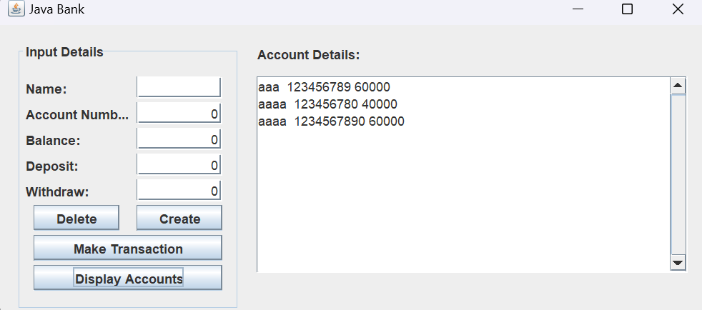
BIKE:
package bikeproject;

public class MountainBike extends Bike{

private String suspension, type;
private int frameSize;

public MountainBike()
{
this("Bull Horn", "Hardtail", "Maxxis", "dropper", 27, "RockShox XC32", "Pro", 19);
}//end constructor

public MountainBike(String handleBars, String frame, String tyres, String seatType, int numGears,
String suspension, String type, int frameSize) {
super(handleBars, frame, tyres, seatType, numGears);
this.suspension = suspension;
this.type = type;
this.frameSize = frameSize;
}//end constructor

public void printDescription()
{
super.printDescription();
System.out.println("This mountain bike is a " + this.type + " bike and has a " + this.suspension + " suspension and a frame size of " + this.frameSize + "inches.");

}//end method printDescription
}//end class MountainBike
---
package bikeproject;

public class BikeDriver {

public static void main(String[] args) {

RoadBike bike1 = new RoadBike();
RoadBike bike2 = new RoadBike("drop", "tourer", "semi-grip", "comfort", 14, 25, 18);
MountainBike bike3 = new MountainBike();
Bike bike4 = new Bike();

bike1.printDescription();
bike2.printDescription();
bike3.printDescription();
bike4.printDescription();
}//end method main
}//end class BikeDriver
----
package bikeproject;

public class MountainBike extends Bike{

private String suspension, type;
private int frameSize;

public MountainBike()
{
this("Bull Horn", "Hardtail", "Maxxis", "dropper", 27, "RockShox XC32", "Pro", 19);
}//end constructor

public MountainBike(String handleBars, String frame, String tyres, String seatType, int numGears,
String suspension, String type, int frameSize) {
super(handleBars, frame, tyres, seatType, numGears);
this.suspension = suspension;
this.type = type;
this.frameSize = frameSize;
}//end constructor

public void printDescription()
{
super.printDescription();
System.out.println("This mountain bike is a " + this.type + " bike and has a " + this.suspension + " suspension and a frame size of " + this.frameSize + "inches.");

}//end method printDescription
}//end class MountainBike
----
spackage bikeproject;

public class RoadBike extends Bike{

private int tyreWidth, postHeight;

public RoadBike()
{
this("drop", "racing", "tread less", "razor", 19, 20, 22);
}//end constructor

public RoadBike(int postHeight)
{
this("drop", "racing", "tread less", "razor", 19, 20, postHeight);
}//end constructor

public RoadBike(String handleBars, String frame, String tyres, String seatType, int numGears,
int tyreWidth, int postHeight) {
super(handleBars, frame, tyres, seatType, numGears);
this.tyreWidth = tyreWidth;
this.postHeight = postHeight;
}//end constructor

public void printDescription()
{
super.printDescription();
System.out.println("This Roadbike bike has " + this.tyreWidth + "mm tyres and a post height of " + this.postHeight + ".");
}//end method printDescription
}//end class RoadBike
---
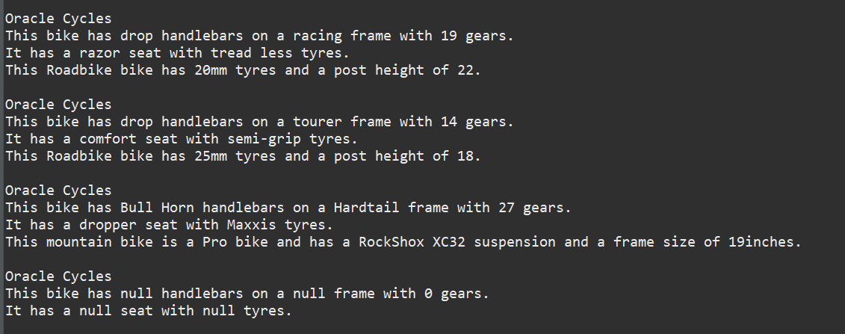

CALCULATOR:
import java.awt.Container;
import javax.swing.JFrame;
import javax.swing.JPanel;
import calculator.CalcPanel;
public class CalcMain {
public static void main(String[] args) {
JFrame theGUI = new JFrame();
theGUI.setTitle("My Calculator");
theGUI.setSize(220,350);
theGUI.setDefaultCloseOperation(JFrame.EXIT_ON_CLOSE);
Container pane = theGUI.getContentPane();
JPanel myPanel = new CalcPanel();
pane.add(myPanel);
theGUI.setVisible(true);
}
}

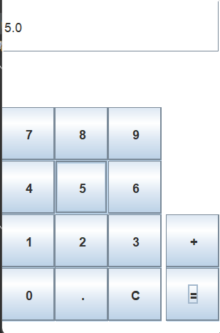
package calculator;
import javax.swing.*;
import java.awt.Color;
import java.awt.event.*;

public class CalcPanel extends JPanel implements ActionListener {
String num1="";
String num2="";
String operator="";
boolean usingFirst=true;
double total=0;
JTextField display;
JButton b1;
JButton b2;
JButton b3;
JButton b4;
JButton b5;
JButton b6;
JButton b7;
JButton b8;
JButton b9;
JButton b0;
JButton bdec;
JButton bclear;
JButton bequals;
JButton bplus;
public CalcPanel()
{
this.setBackground(Color.white);
setLayout(null);
display=new JTextField();

b1=new JButton("1");
b2=new JButton("2");
b3=new JButton("3");
b4=new JButton("4");
b5=new JButton("5");
b6=new JButton("6");
b7=new JButton("7");
b8=new JButton("8");
b9=new JButton("9");
b0=new JButton("0");
bdec=new JButton(".");
bclear=new JButton("C");
bequals = new JButton( "=");
bplus=new JButton("+");
display.setBounds(0,0,205,50);
b1.setBounds(0,200,50,50);
b2.setBounds(50,200,50,50);
b3.setBounds(100,200,50,50);
bplus.setBounds(154,200,50,50);
b4.setBounds(0,150,50,50);
b5.setBounds(50,150,50,50);
b6.setBounds(100,150,50,50);
b7.setBounds(0,100,50,50);
b8.setBounds(50,100,50,50);
b9.setBounds(100,100,50,50);
b0.setBounds(0,250,50,50);
bdec.setBounds(50,250,50,50);
bclear.setBounds(100,250,50,50);
bequals.setBounds(154,250,50,50);

add(b1);
add(b2);
add(b3);
add(b4);
add(b5);
add(b6);
add(b7);
add(b8);
add(b9);
add(b0);
add(bdec);
add(display);
add(bclear);
add(bequals);
add(bplus);

b1.addActionListener(this);
b2.addActionListener(this);
b3.addActionListener(this);
b4.addActionListener(this);
b5.addActionListener(this);
b6.addActionListener(this);
b7.addActionListener(this);
b8.addActionListener(this);
b9.addActionListener(this);
b0.addActionListener(this);
bequals.addActionListener(this);
bplus.addActionListener(this);
bclear.addActionListener(this);
bdec.addActionListener(this);

}
public void actionPerformed(ActionEvent e){
String s=e.getActionCommand();
if(s.equals("1")||s.equals("2")||s.equals("3")||s.equals("4")||
s.equals("5")||s.equals("6")||s.equals("7")||s.equals("8")||
s.equals("9")||s.equals("0")||s.equals("."))
{
if(usingFirst)
{

num1=num1+s;
display.setText(num1);
}
else
{
num2=num2+s;
display.setText(num2);
}
}
if(s.equals("+"))
{
usingFirst=false;
operator="+";
}
if(s.equals("="))
{
switch(operator){
case "+":
total=Double.parseDouble(num1)+Double.parseDouble(num2);
display.setText( ""+total );
break;
}
usingFirst=true;
num1="";
num2="";
operator="";
}
if(s.equals("C"))
{
display.setText( "" );
usingFirst=true;
num1="";
num2="";
total=0;
}
}
}
